Max Consecutive Ones

Given a binary array nums, return the maximum number of consecutive 1's in the array.

Input: nums = [1,1,0,1,1,1]

Output: 3

Explanation: The first two digits or the last three digits are consecutive 1s. The maximum number of consecutive 1s is 3.

# Solution:

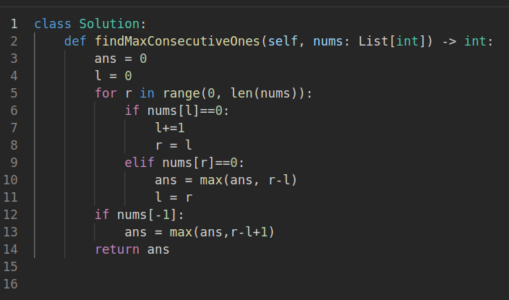

Output:

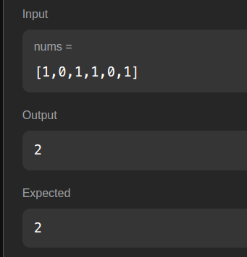

# Explanation:

There are 2 variables max and current. Current keeps track of the current count of consecutive ones. It is incremented when 1 is read and reset when 0 is read. In every iteration, the max value is set as maximum between max and current.

Time Complexity: O(n) Space Complexity: O(1)

Longest Substring with At Least K Repeating Characters

# Given a string s and an integer k, return the length of the longest substring of s such that the frequency of each character in this substring is greater than or equal to k. If no such substring exists, return 0.

# Input: s = "aaabb", k = 3

Output: 3

Explanation: The longest substring is "aaa", as 'a' is repeated 3 times.

# Solution:

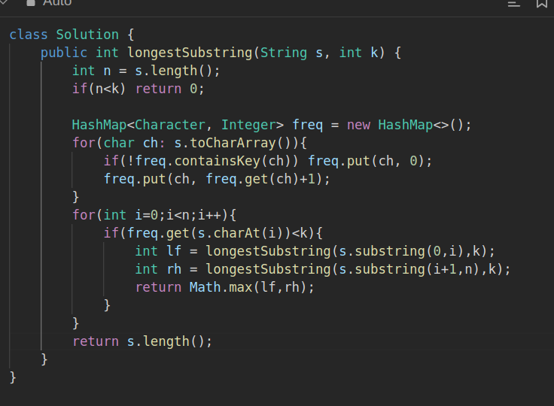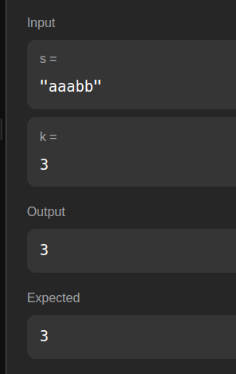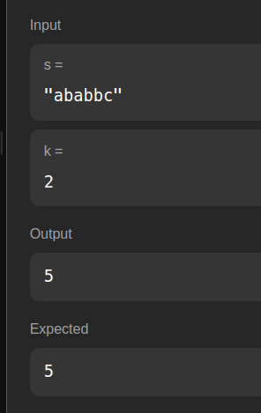

Output:

Time Complexity: O(n**2)

Subarray Sum Equals K

Given an array of integers nums and an integer k, return the total number of subarrays whose sum equals to k. A subarray is a contiguous non-empty sequence of elements within an array.

Input: nums = [1,2,3], k = 3

Output: 2

# Solution:

Output:

Approach: